5 Top Tips for Selling your Home
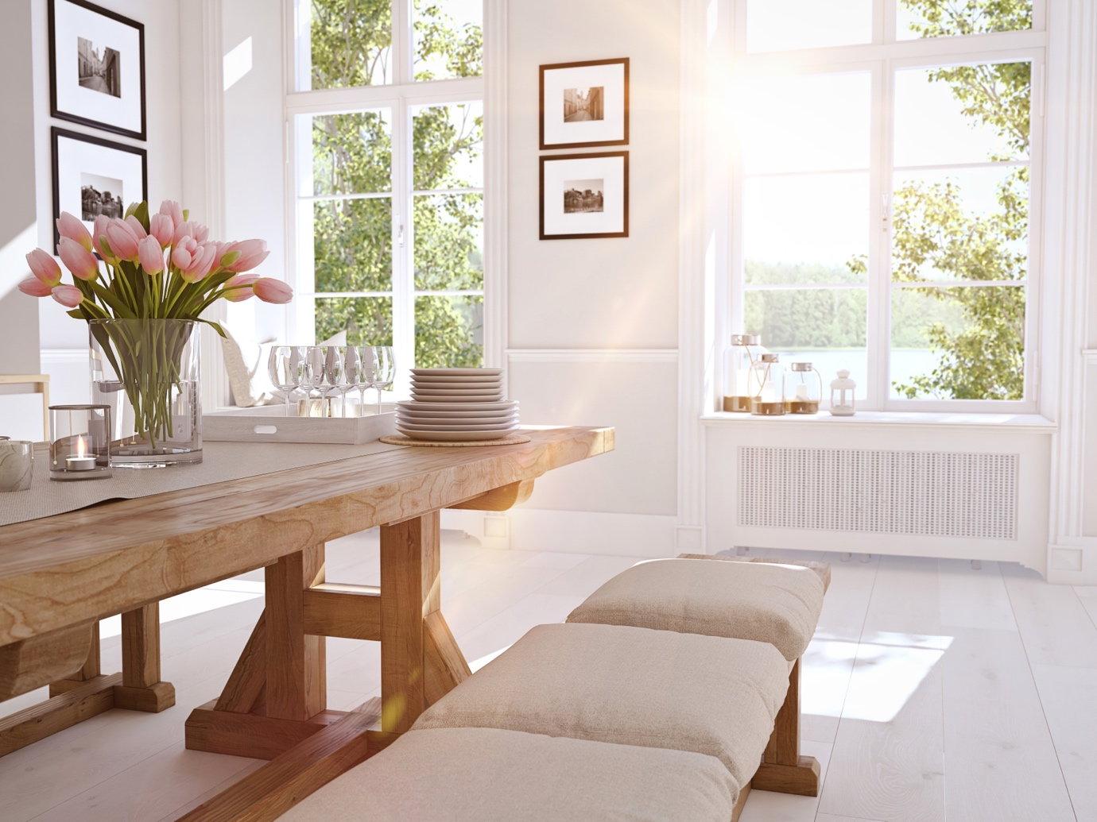
Small changes can make a big difference when it comes to selling your home. Follow these tips to make your house as attractive as possible for prospective new buyers.

- Increase kerb appeal
First impressions always count – from the outside, tidy the garden, weed the driveway and jetwash the patio – repair damaged fences and clean your windows before any viewings.
- Choose neutral colours
It’s a classic – keep your colours subtle to increase the appearance of space and help buyers visualise them making their own mark upon the property. You can still inject some warmth with choice accent colours on soft furnishings such as cushions and rugs.
- Clean & de-clutter your property
Give your place a spring clean and tidying away unsightly items in cupboards to help create more space and make it easier for potential buyers to think about how they can see themselves living there.
- Consider the time of year
It’s challenging to make a house look as attractive in Winter as in other times, so think about holding on if you can – improved weather, brighter days and plants in bloom can give your place a natural makeover.
- Presentation
Last-minute care and attention to the little details before estate agents come to take photos or potential buyers arrange a viewing can pay big dividends. Turn your lights on, ensure beds are made, curtains are tied back and kids toys are tidied away. Conceal pet beds & toys, and tactically place fresh flowers and air fresheners to increase the appeal for visitors.

