HLP Social Media – Moving Home – Sale Prices

For sale - to the highest bidder?
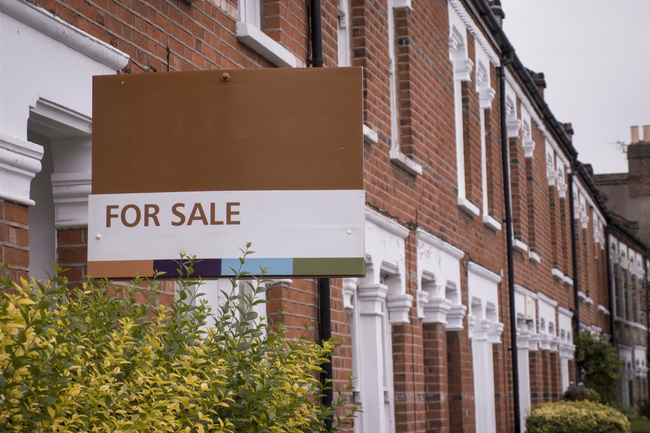
When selling your home, should you always sell to the highest bidder? On paper it might make financial sense, but it’s not always that simple. Consider their position, are they a first-time buyer with no chain and a load of cash ready to buy – or are they caught up in a long and complex chain, that could fall through at any minute? Ask yourself, what’s the most important thing to you – will you hold out for that high offer, or take a lower amount for a quick sale?

