How Much Stamp Duty Will I Pay?

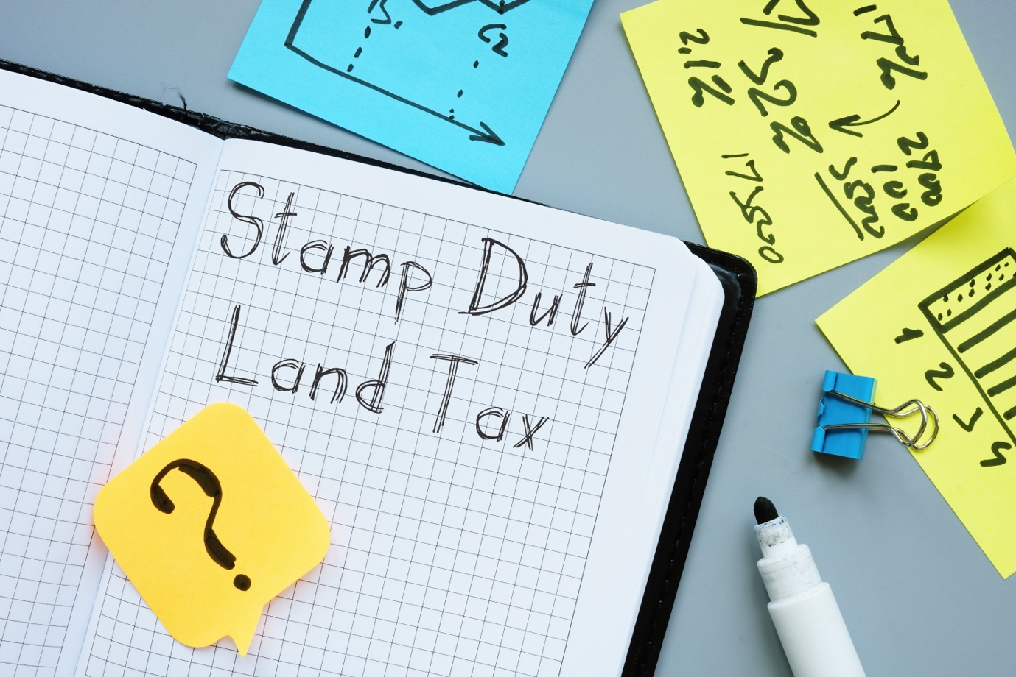

With the excitement of buying a new home, it can be easy to overlook some of the big payments you may have to make as part of the process.

Here we help explain how you can calculate the Stamp Duty you might have to pay when you move home.

Stamp Duty is a tax that may be payable when buying your home, in England and Northern Ireland (as of April 2025), any property over £125,000 is subject to a tax. In Scotland, there’s a slightly different policy, but the concept is the same – it’s known as Land and Buildings Transaction Tax, or Land Transaction Tax in Wales¹.

There’s an easy way to find out how much tax you might have to pay on your property sale – simply take a look at these Government calculators for your respective country of residence.

- England & Northern Ireland: https://www.tax.service.gov.uk/calculate-stamp-duty-land-tax/#/intro
- Wales: https://gov.wales/land-transaction-tax-calculator
- Scotland: https://revenue.scot/calculate-tax/calculate-property-transactions
(These links are correct as of April 2025. Please visit the official government sites for up to date information).
We advise on a wide range of topics when helping you move home, so speak to us to get a clearer picture. Book an appointment today.

YOUR HOME MAY BE REPOSSESSED IF YOU DO NOT KEEP UP REPAYMENTS ON YOUR MORTGAGE.
Add Your Broker Fee Disclosure Here

Source:
GOV.UK (2025). Stamp Duty Land Tax. Available at: https://www.gov.uk/stamp-duty-land-tax/residential-property-rates
‌
All the information in this article is correct as of the publish date 29th August 2024. The opinions expressed in this publication are those of the authors. The information provided in this article, including text, graphics and images does not, and is not intended to, substitute advice; instead, all information, content, and materials available in this article are for general informational purposes only. Information in this article may not constitute the most up-to-date legal or other information.
Please be aware that by clicking on to any of the above links you are leaving our website. Please note that neither we nor HL Partnership Limited are responsible for the accuracy of the information contained within the linked site(s) accessible from this page.

